# Rideshare Case Study – Dhwani Shah

## Market size & Opportunity

### Market size:

### Based on Revenue over the quarters:

* Q4 2020 = 25,261,859.60
* Q1 2021 = 27,962,187.74
* Q2 2021 = 42,159,848.73

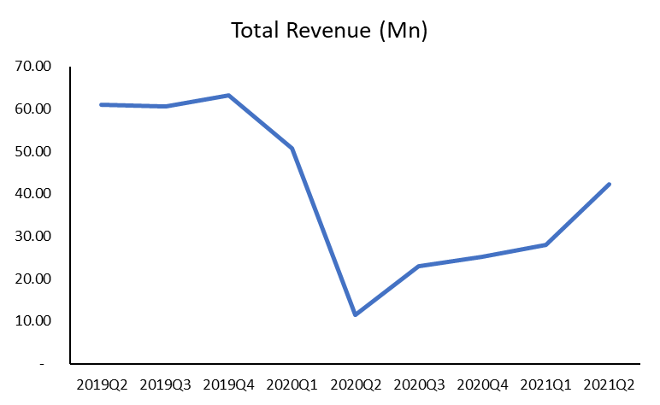

*Total Revenue of All companies in each Quarter (Market size in Revenue)*

Observation: The Industry saw a steep decline during the COVID period. It has since started its recovery and is currently above 50% of pre-COVID revenues.

### Market Share Distribution based on Revenue

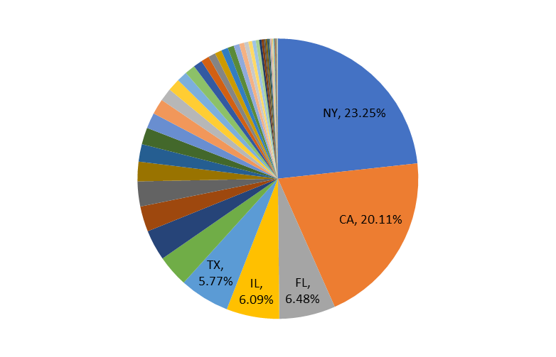

*Region-wise share % of the industry*

New York and California state are the major regions which are contributing 23% and 20% respectively.

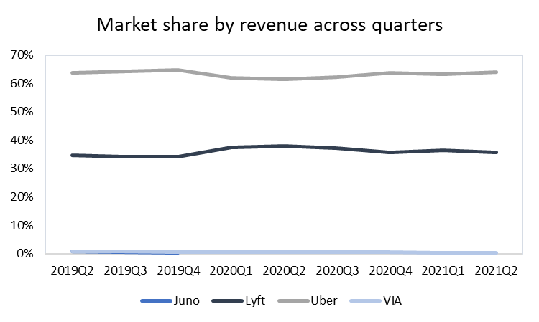

* Throughout the quarters, the market share of Lyft is approximately 35% whereas market share of Uber is approximately 62-63%. Overall, Uber has bigger market share.
* During COVID, Lyft has a slightly marginal increase in the market whereas Uber has a marginal dip.

### Customers



*No. of Customers using the apps across all quarters in each company*

#### Observations:

* During COVID, Uber lost some customer market share and Lyft gained a nearly equivalent amount of customer market share.
* Post-COVID, Uber has almost completely regained its lost market share.
* Even though Lyft saw an increase in customers during COVID, it was unable to retain the customers market share post-COVID.

### Key Performance Indicators

The following metrics could have possibly influenced the market share evolution:

* Rides per customer
* Cancellation rate
* Number of customers
* Retention ratio

## Ride Cancellations



* Number of cancelations have been decreasing over the quarters.



*Cancellations in Each company over the quarters*

* Cancellations more in Uber because the number of customers is more. Also, the market share of Uber is much higher than Lyft.

## Geography Analysis

* Lyft does not have its operations in Puerto Rico
* Lyft is performing better in Oregon and South Dakota
* Uber is outperforming Lyft in terms of revenue in all of the other states. Uber has the most significant outperformance in New York, California, Illinois, Florida and Texas

## Ride Times and Ride Distances



* During Surge, Uber has more customers even while comparing to Lyft – Prime Time Fare type

## Customer Loyalty

### Customer Retention



* The retention ratio over the quarters for both Lyft and Uber are almost the same.
* The difference in retention ratio till 2020 Q2 has been less than 1% (Lyft higher). Post-COVID, Uber has slightly more retention ratio

### Cross-app Usage

* Uber is more preferred than Uber looking at the number of times a particular USER_ID has used Uber more than Lyft

## Driver

If I was a driver, I would prefer to work for Uber

* High Market share so more customer base
* Uber is outperforming in majority of the US states
* As I would get more customers, income would be higher

# Conclusion

According to the analysis, I would recommend Advent to purchase Uber rideshare company due to the following reasons:

* Market leader with a share of approximately 60% in the revenues
* Customer base is also dominant with approximately 60%
* Though the number of customers in high, the retention rate is almost the same as Lyft which has lower customer base of 30%
* Uber is dominant rideshare company in nearly all the US states
* Observing the cross-app usage, many Users use both Lyft and Uber, but the number of times Uber is used is much higher.